# C:\Users\James\AppData\Local\Microsoft\Windows\INetCache\Content.Word\1510864_10152222978819882_1653651865_n.jpg

Deputy Project Manager’s Contribution Report

#### Max Holland, James Oatley

# Document Control

|  |  |  |  |  |
| --- | --- | --- | --- | --- |
| Version Number | Modified By | Date | Section(s) Modified | Comments |
| *1.0* | *M. Holland* | *12/06/2014* | *All* | *-* |
| 1.1 | J. Oatley | 12/06/2014 | 4 | *Added name labels to Git commit graphs.* |
|  |  |  |  |  |
|  |  |  |  |  |
|  |  |  |  |  |
|  |  |  |  |  |
|  |  |  |  |  |
|  |  |  |  |  |
|  |  |  |  |  |
|  |  |  |  |  |
|  |  |  |  |  |
|  |  |  |  |  |

# Introduction

This document serves partly as an extended software report of the entire project, and also as a measure of coding contribution throughout the project, by providing raw evidence from the development tools JIRA and Github.

# JIRA Burndown Reports

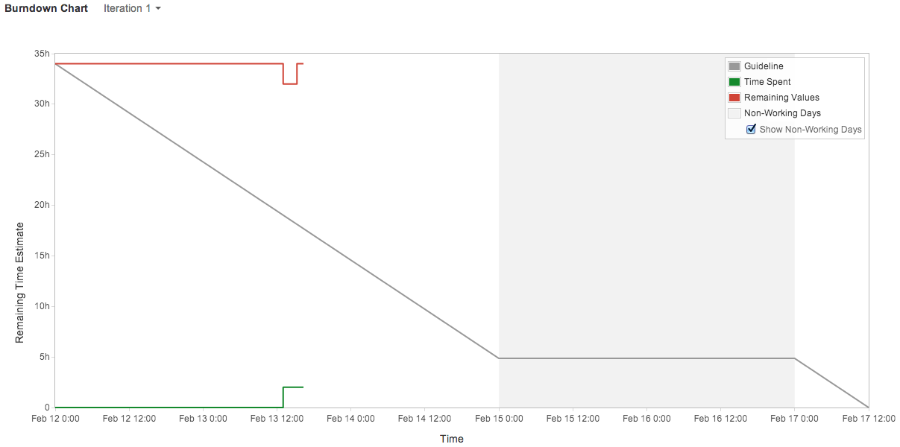

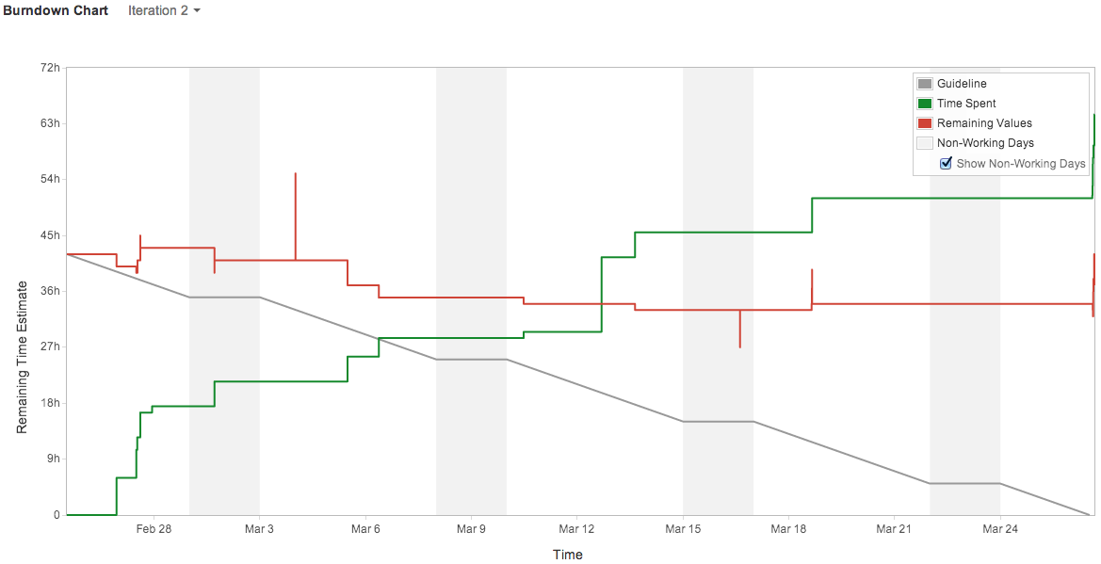

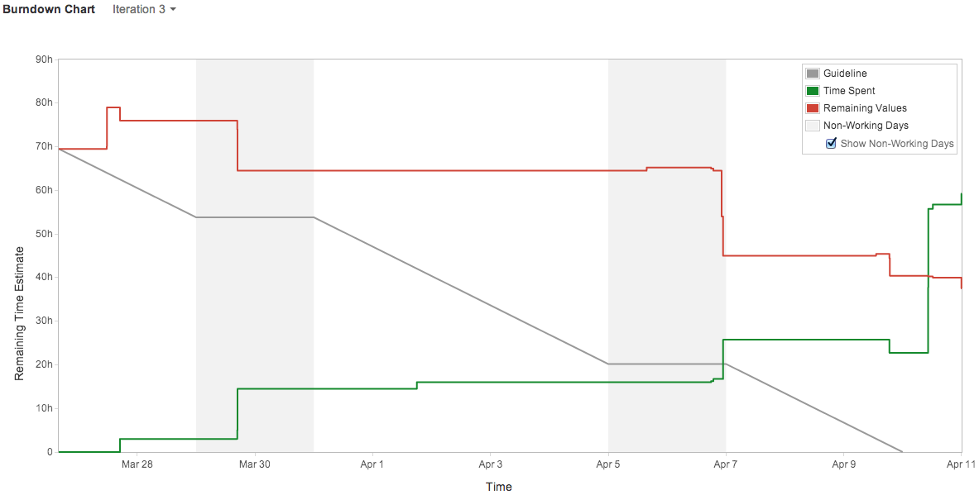

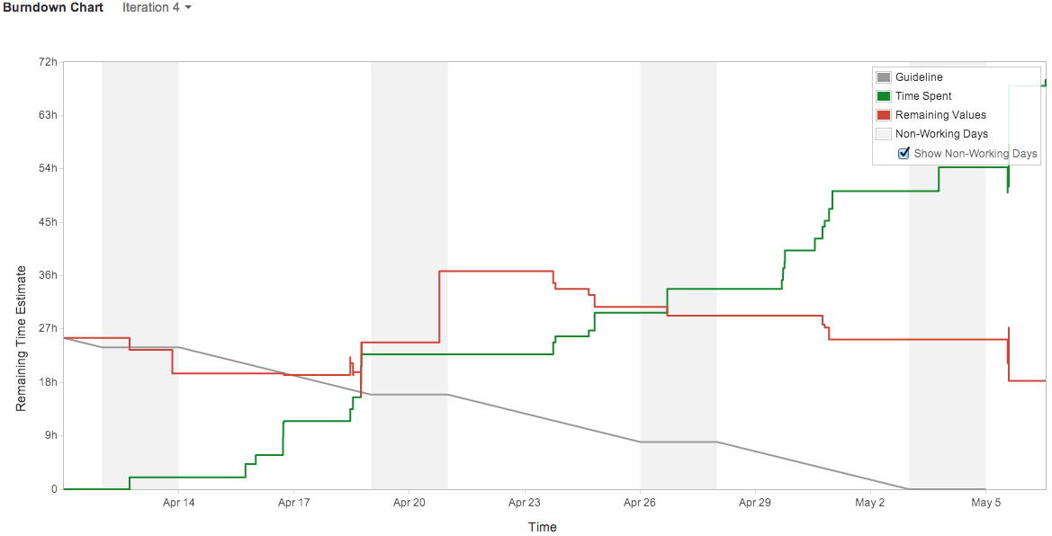

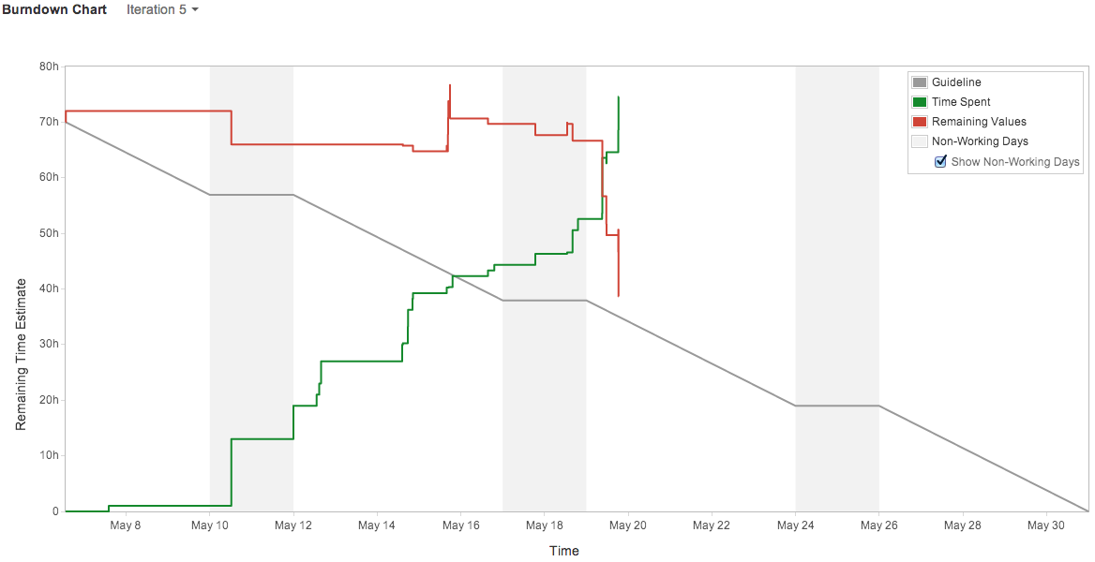

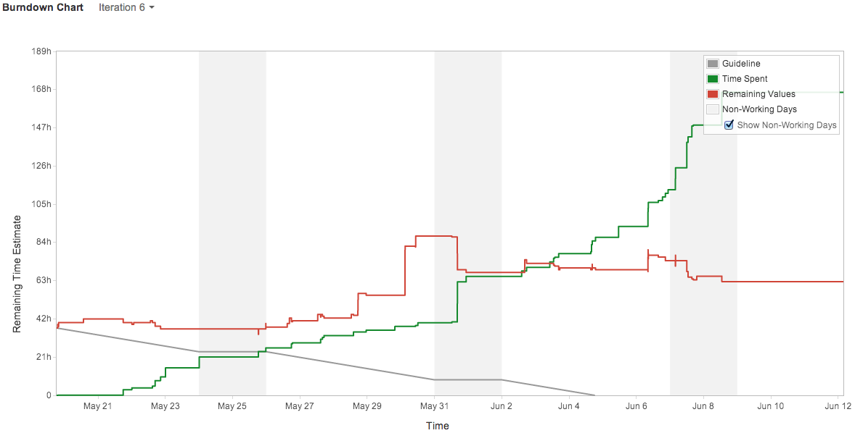

# Macintosh HD:Users:Max:Desktop:Screen Shot 2014-06-12 at 03.41.57.pngJIRA Cumulative Flow Diagram

# GitHub Commit Log

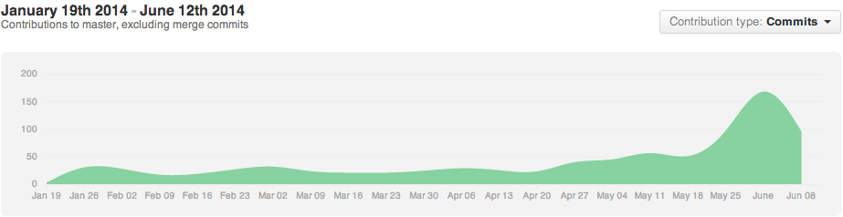

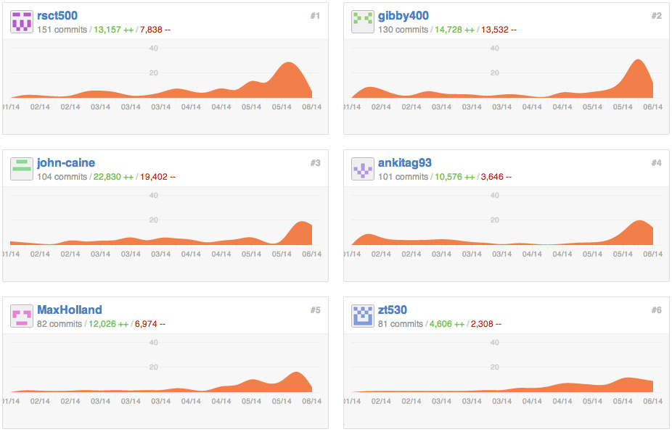

Zayyad Tagwai

Max Holland

Ankita Gangotra

John Caine

James Oatley

Roger Tan

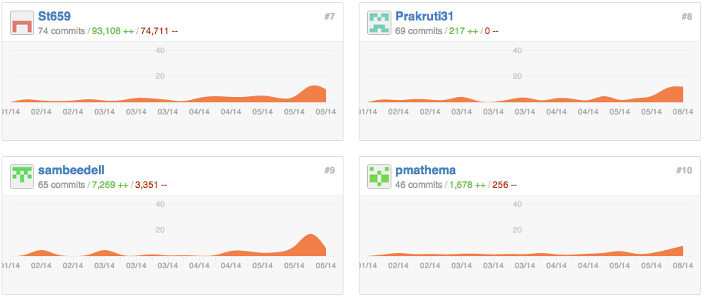

Prakruti Sinha

Steve Thorpe

Paul Mathema

Sam Beedell

